**ISS4014 – Database Systems and Web Integration**

**Chapter 15 – Activities and Homework**

**Write responses and images in the response document.**

**Chapter 15 Review Questions (10 points - 2 points each)**

1. What is ODBC, DAO and RDO? How are they related?
2. What is the difference between DAO and RDO?
3. What are the three basic components of the ODBC architecture?
4. What is OLE-DB used for, and how does it differ from ODBC?
5. How does ADO complement OLE-DB?

**Chapter 15 Problems (10 points)**

**Extracting data from an Access database file using ODBC into an Excel Table.**

1. (3 points) (Windows Required) Using the Chapter 15 Order DB Access database file (“Ch15_orderdb.mdb”), Excel, and ODBC, import the records from the orders table where the **ven_code** is equal to '**CART**' from the Access database into Excel.
   1. If you do not have Excel or are using a Mac, you can use the Remote VDI (Science) Machine at <https://pointloma.workspaceoneaccess.com/> to complete this problem.
      1. You will need to download the student files onto the virtual machine from Canvas and copy the Ch15_orderdb.mdb file to the drive so you can access it.
      2. Note: nothing is saved on the VM after you log off.
   2. Start the ODBC Data Source application (64bit if given a choice) and create a User DSN called ‘Ch15_OrderDB’ using the Microsoft Access Driver and connecting it to the Ch15_orderdb.mdb file.
      1. If using the VDI virtual machine, copy the Ch15_orderdb.mdb file to the **C: \Users\<your user>** folder location
      2. To connect the Access file to the ODBC driver, click on “Select” in the database section.
      3. Under the Advanced button, enter the Login Name of “Admin” with no password.
   3. Start Excel, open a blank workbook, go to the Data tab, and click on Get Data.
   4. Select a data query from Other Source – From ODBC.
      1. If the “Ch15_OrderDB” DSN is available, keep it selected and click on the “Advanced options”.
      2. Select the DSN=Ch15_OrderDB from the drop-down list. If the DSN drop-down menu does not appear, enter a connection string manually. **DSN=Ch15_OrderDB**
      3. If the SQL Statement text box does not appear, click on the Advanced Options link to open the SQL Statement text box.
      4. Enter an SQL query to select only the “CART” vendor codes from the “ORDERS” table. **Select * from ORDERS where ven_code = 'CART'** (You can open the Access database to view the column names if you have MS Access or are using the Science VDI). Make sure to use single quotation marks and avoid using stylistic quotation marks. Click “OK”.
      5. Enter the user ID Admin and no password and click “Connect” if prompted.
      6. The query dataset windows should appear with the query results.
      7. Before clicking on the “Load” button. **Take a screenshot of the query result window, including the ODBC command at the top of the window, and paste the image into the response document under the Problem 1 Image – Excel ODBC Data Query heading.**
      8. Click “Load” to load the data into Excel.
      9. Save or discard the Excel file.
2. (4 points) Create a PHP page that will extract the vendor data from the Ch15_orderdb MySQL database table and display the data on a web page.
   1. Using MySQL and MySQLWorkbench, create the ch15_orderdb database and load the ch15_orderdb tables and data.
   2. Using any editor (Notepad++, or VS Code recommended) open the Ch15_vendorlist.php file in the student file folder. This should be the same source code found in Figure 15.12 in the text.
      1. Modify the H1 tag to include your name.
      2. The program was written to query data from an ODBC data source. Modify the database connection commands to query data from a MySQL data source using the following (see the image below for a reference of the completed changes):

* Add a ‘ **$DBName = "ch15_orderdb";** ’ statement below the <?php tag.
* Change the ‘$dbc =’ statement to ‘ **$dbc = @mysqli_connect("localhost", "root", "", $DBName);** ’
* change the ‘$rs =’ statement to ‘ **$rs = mysqli_query($dbc, $sql);** ’
* change the ‘while’ statement to ‘ **while ($row = mysqli_fetch_assoc($rs))** ’
* change each ‘$VEN_’ assignment to the following pattern: ‘ **$VEN_CODE = $row["VEN_CODE"];** ’
* change the “odbc_close($dbc);” at the bottom of the PHP code to a ‘ **mysqli_close($dbc);** ‘

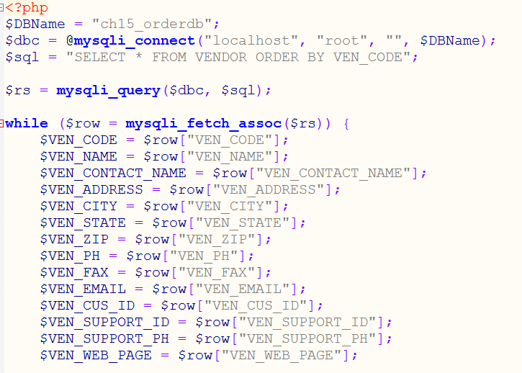

1. Name the document VendorMySQL.php and save the file in your **/xampp/htdocs** folder.
   1. Using the XAMPP controller, ensure the MySQL database and Apache servers are running.
   2. Open a browser and enter the URL <http://localhost/VendorMySQL.php>
   3. **Take a screenshot of the webpage showing the title (with your name) and the first one or two output records and copy it into the response document under the** **Problem 2 Image – VendorMyQL.php heading.**
2. (3 points) Start your AWS Academy Lab environment so your MySQL database you created in an earlier lab activity is activte. Create a copy of the VendorMySQL.php file and name it VendorAWS.php. Modify the PHP file so it connects to the AWS MySQL database.
   1. Log into AWS, go to your MySQL database, and note the Endpoint. Copy the Endpoint name of the database to use in the following steps.
   2. Open MySQL Workbench and connect to the AWS MySQL database.
      1. Connect MySQL Workbench to the AWS database, create a ch15_orderdb database, and run the database load script.
         1. You may notice that MySQL is case-sensitive with table names, and you will get an error if the create table command and the insert commands do not use the same case for the table names. Correct any issues with the load script and rerun. Ensure the data gets loaded correctly.
   3. In the VendorAWS.php file, make the following modifications:
      1. Modify the ’$dbc =’ command to connect the AWS using the Endpoint URL, name and password.
      2. Modify the H1 tag to read “… using AWS Server…”
   4. **Take a screenshot of the webpage showing the title (with your name and AWS) and the first one or two output records and copy it into the response document under the Problem 3 Image – VendorAWS.php heading.**
   5. **Take a screenshot of the php source code segment showing the lines creating the database connection and copy it into the response document under the Problem 3 Image – php source code heading.**
   6. **Also** – **Copy and Paste the name of your AWS MySQL database endpoint URL Here (Do not delete your database until after this assignment is graded).**